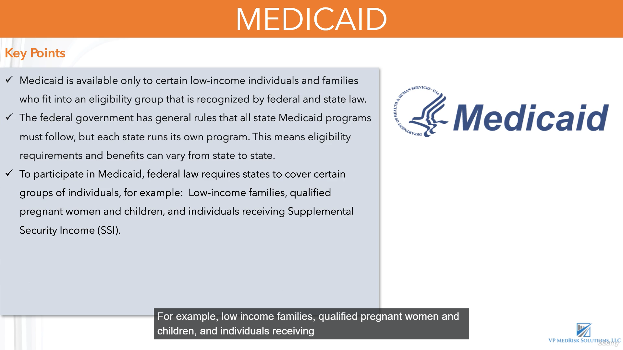
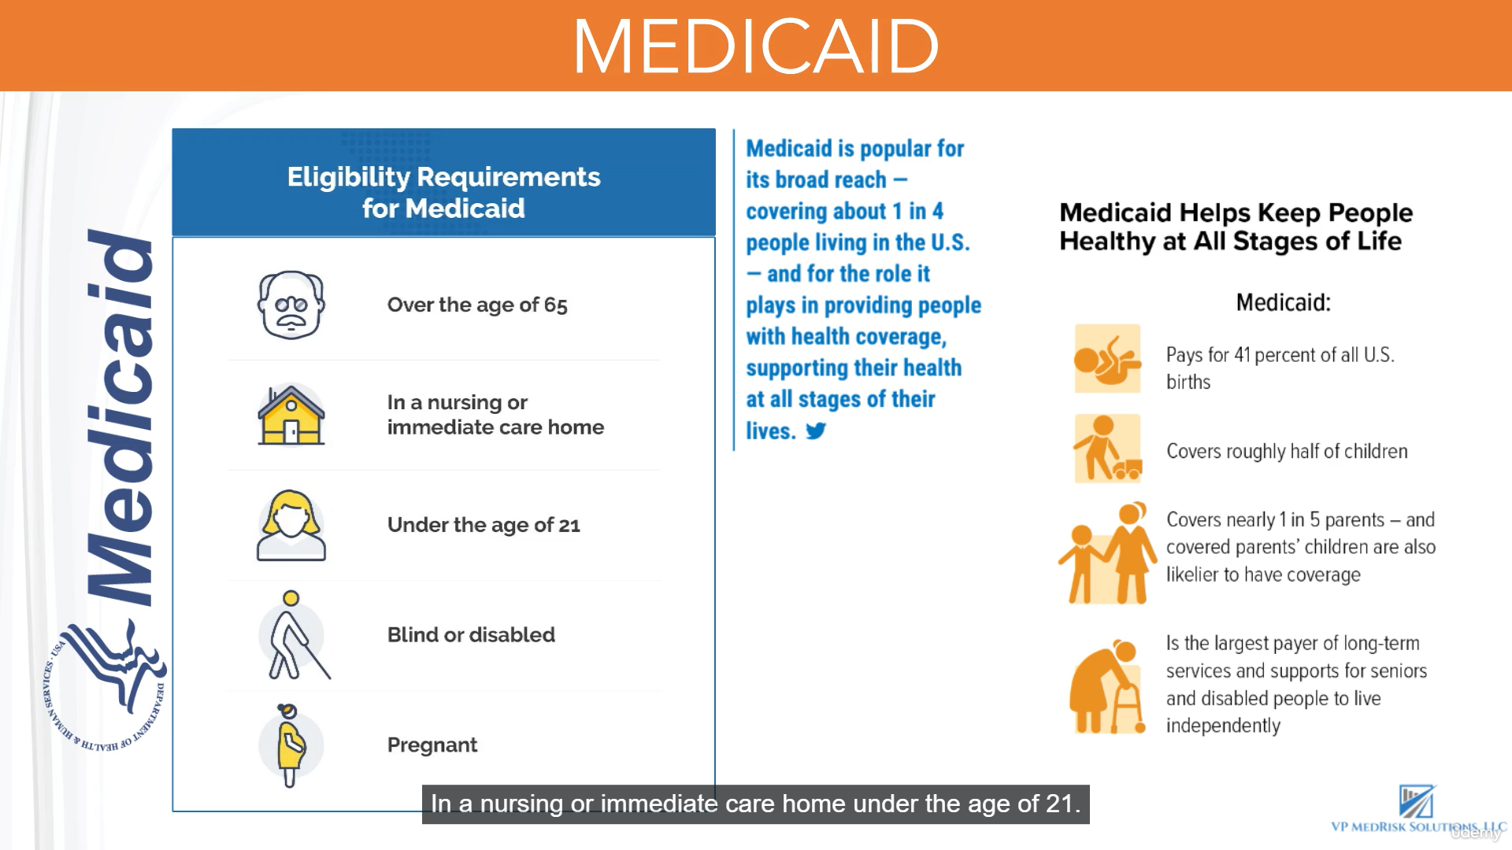

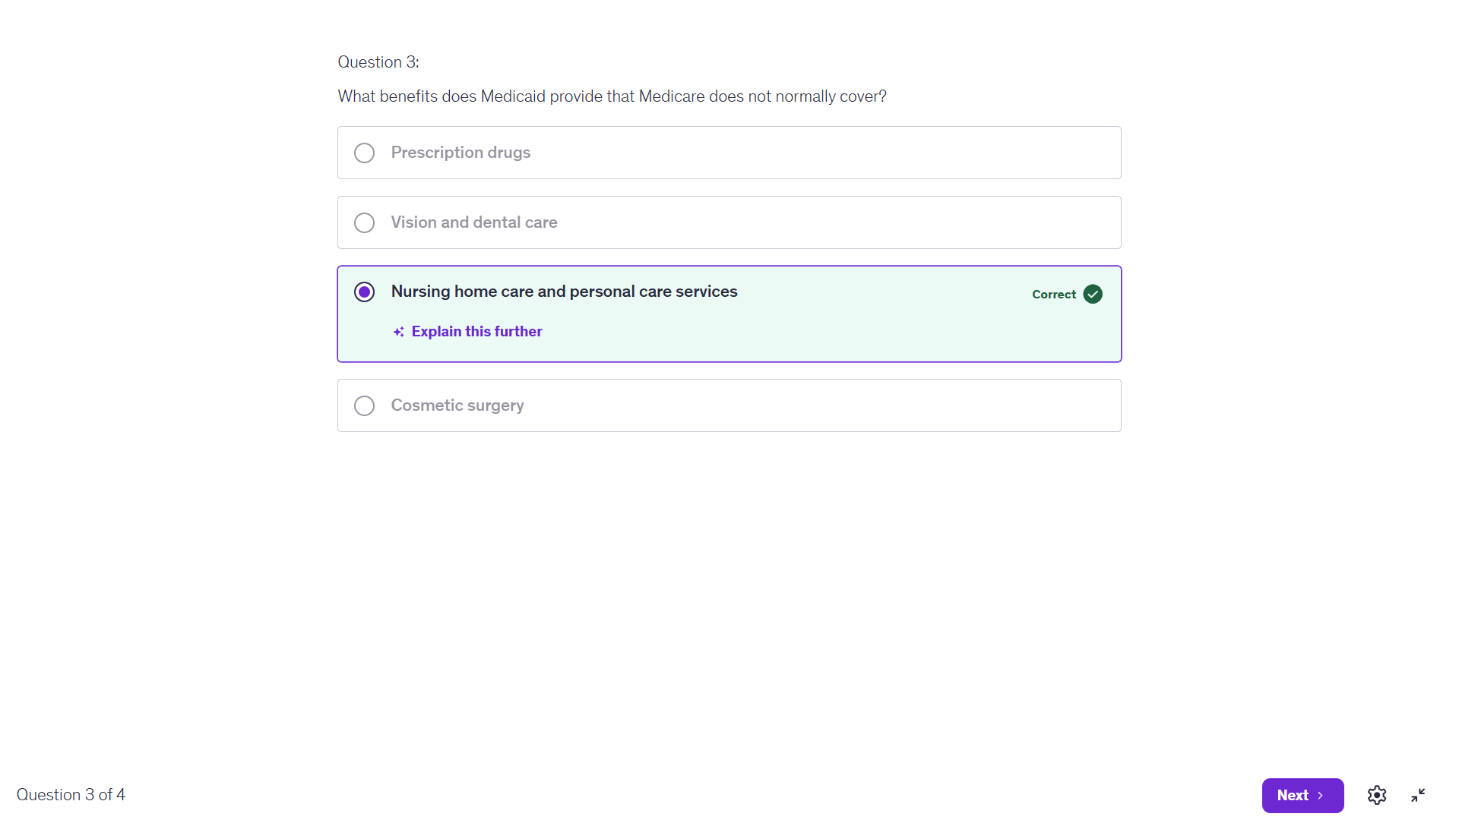
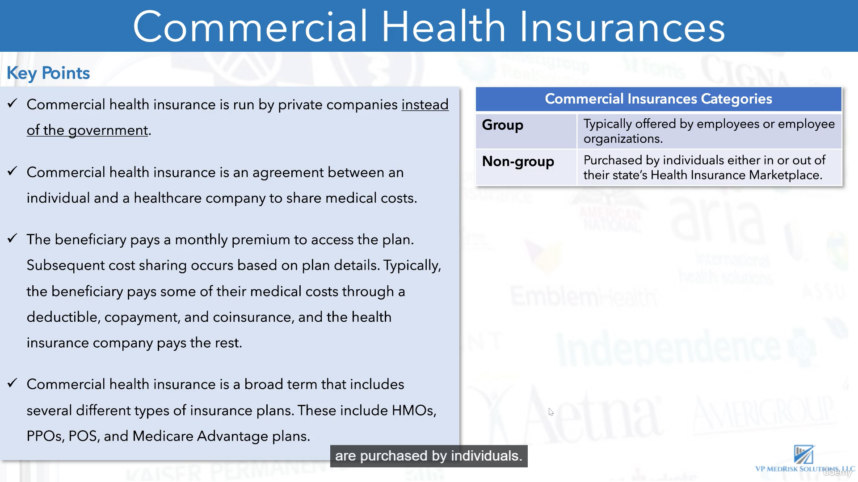
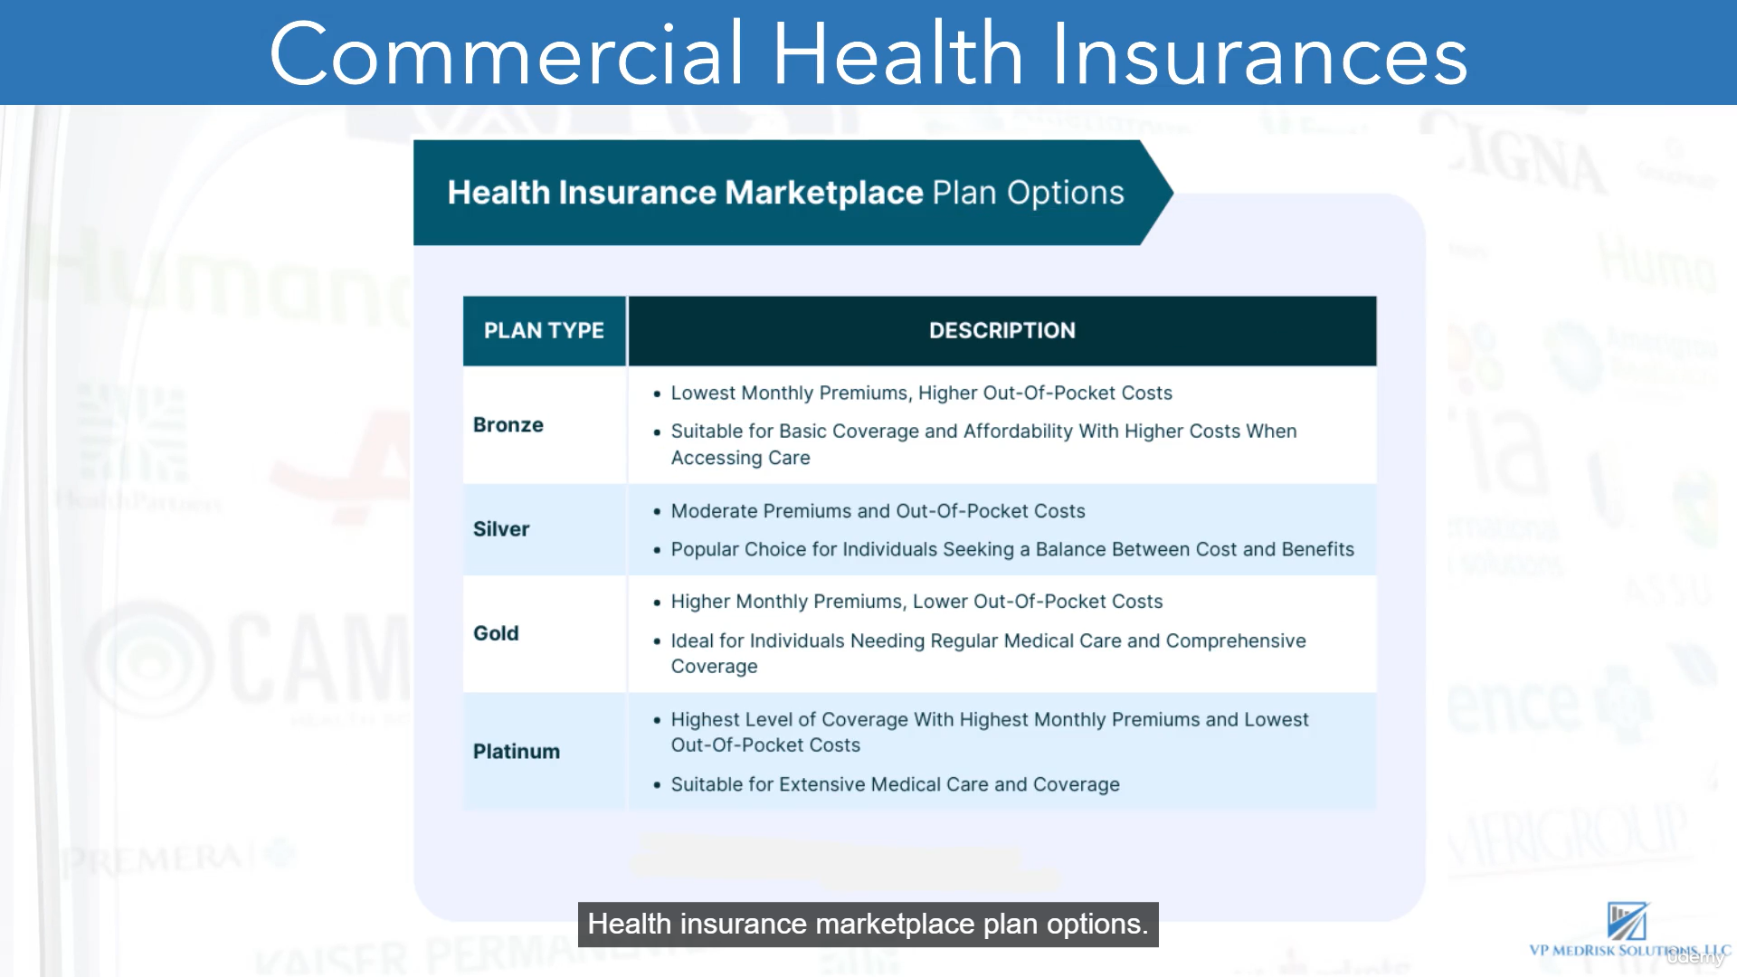
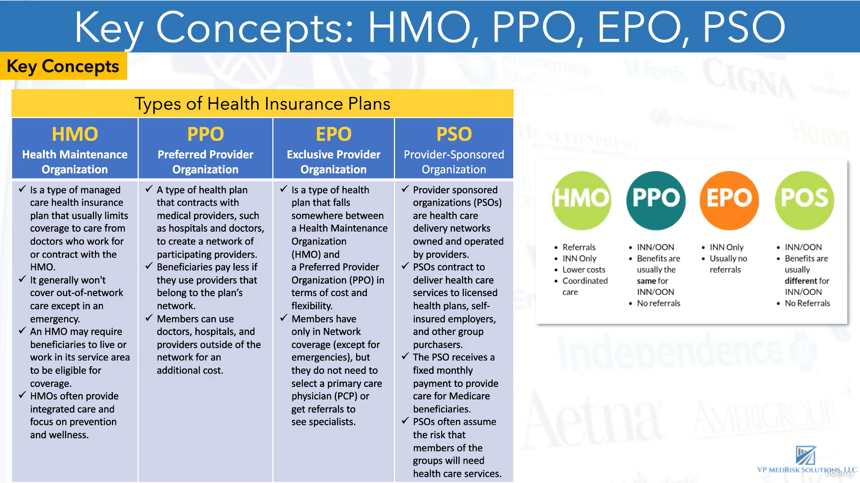
HMOs are prepaid managed care plans that combine financing and care delivery - they pay providers a fixed amount (often via capitation) to treat enrolled patients, creating incentives for cost-efficient, high-quality care.

Best for people who want:
Lowest premiums compared to other plans

Consistent, coordinated care through one main doctor

- HMO: Cheapest on average, but most restrictive. You usually must choose a primary care doctor, get referrals for specialists, and stay in-network except for emergencies.

- PPO: Most flexible, but usually costs more. You can see specialists without referrals and may get partial coverage for out-of-network care.

- EPO: A middle ground. You usually do not need referrals, but you generally get no coverage for out-of-network care except emergencies.

- PSO: This is likely a typo for POS in US health insurance. A POS plan usually requires a primary care doctor and referrals like an HMO, but it also offers some out-of-network coverage like a PPO, typically at higher cost.

Simple way to remember it
HMO = low cost, more rules.
PPO = higher cost, more freedom.
EPO = no referrals, but in-network only.
POS = referral-based, but some out-of-network flexibility.
Tips to remember
HMO: usually no out-of-network coverage except emergencies.
PPO: out-of-network care is covered, but you pay more.
EPO: usually no out-of-network coverage except emergencies.
POS: mainly in-network care, but some out-of-network coverage is possible, often with referral rules.
So the correct idea is: PPO gives the most flexible out-of-network coverage, while POS can also cover out-of-network care, but not as broadly as PPO.

